**Agile methodology**

**What is Agile methodology?**

The Agile methodology is a practice that encourages continuous development and testing throughout the software development lifecycle of a project.

Agile methodologies attempt to produce the proper product through small cross-functional self-organizing teams that produce small pieces of functionality on a regular basis, allowing for frequent customer input and course correction as needed. In doing so, Agile tries to address the issues that traditional "waterfall" methodologies of delivering huge products over extended periods of time encounter, such as client requirements changing frequently and resulting in the delivery of incorrect products.

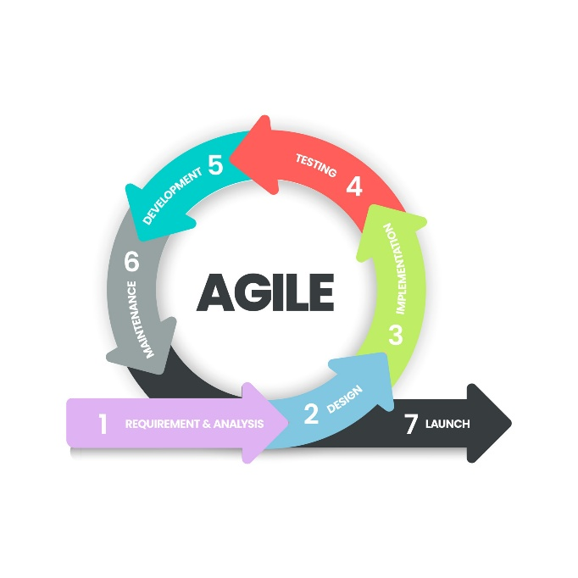

**Stages of Agile Monitoring**

**1: Requirements**

* In this stage, the project team identifies and documents the needs and expectations of various stakeholders, including clients, users, and subject matter experts.
* It involves defining the Project's Scope, objectives, and requirements.
* Establishing a budget and schedule.
* Creating a project plan and allocating resources.

**2: Design**

* Developing a high-level system architecture.
* Creating detailed specifications, which include data structures, algorithms, and interfaces.
* Planning for the software's user interface.
* Types:
* **Software Design**

The Product Owner gathers their development team and introduces the requirements developed during the previous stage during the first iteration. The team then explores how to approach these objectives and suggests the tools required to obtain the best outcome. The developers debate feature implementation and the internal structure of the come in subsequent iterations.

* **UI/UX Design**

The designers build a rough mock-up of the user interface during this stage of the SDLC. When it comes to consumer products, the user interface and user experience are crucial. As a result, it's a good idea to look at potential competitors to evaluate what they're doing correctly — and, more importantly, what they're doing poorly.

**3. Development and Coding**

* Writing the actual code for the software.
* Conducting unit testing to verify the functionality of individual components.

**4: Integration and Testing**

This phase involves several types of testing:

* Integration Testing: Ensuring that different components work together.
* System Testing: Testing the entire system as a whole.
* User Acceptance Testing: Confirming that the software meets user requirements.
* Performance Testing: Assessing the system's speed, scalability, and stability.

**5. Implementation and Deployment**

* Deploying the software to a production environment.
* Put the software into the real world where people can use it.
* Make sure it works smoothly in the real world.
* Providing training and support for end-users.

**6: Review**

* Addressing and resolving any issues that may arise after deployment.
* Releasing updates and patches to enhance the software and address problems.

**Benefits of Agile development methodology**

The Advantages of the Agile Model are as follows:

* **Flexibility and Adaptability**: Agile can quickly adapt to changes, allowing teams to respond to new customer needs and market conditions.
* **Improved Collaboration**: Agile encourages constant communication between developers and stakeholders, ensuring the product meets user expectations.
* **Faster Delivery**: Agile ensures quicker releases, keeping customers engaged and their feedback incorporated early.
* **Enhanced Quality and Customer Satisfaction**: Agile focuses on customer feedback, ensuring the product meets their needs and delivering high-quality results.
* **Iterative Development**: Work is done in small, manageable steps, allowing for regular improvements and quick adjustments.
* **Transparency**: Agile keeps stakeholders informed at every stage, ensuring clarity and alignment.
* **Quality Assurance**: Agile prioritizes quality, ensuring the product meets users' expectations through continuous improvements.
* **Continuous Improvement**: Regular feedback ensures the product keeps improving, preventing last-minute issues and maintaining high quality.

**Types of Agile Methodologies**

Agile is a flexible framework with several approaches, each suited for different project needs. Here are some of the most common Agile methodologies:

**1. Kanban**

**2. Scrum**

**3. Extreme Programming (XP)**

